**Resultados v2 Fioretti**

**Tabela 1.** Caracterização da amostra estudada.

|  |  |
| --- | --- |
|  | Summary |
| Tamanho da amostra | 4,263 |
| Idade, média ± dp | 60.3 ± 14.1 |
| Sexo |  |
| Masculino | 1,217 (28.6%) |
| Feminino | 3,045 (71.4%) |
| Hipertensão Arterial (HAS) |  |
| Não | 2,668 (62.6%) |
| Sim | 1,594 (37.4%) |
| Diabetes Mellitus (DM) |  |
| Não | 3,359 (78.8%) |
| Sim | 903 (21.2%) |
| Tabagismo |  |
| Não | 3,784 (88.8%) |
| Sim | 478 (11.2%) |
| Dislipidemia |  |
| Não | 3,592 (84.3%) |
| Sim | 668 (15.7%) |
| Doença Carotídea (USG) |  |
| Não | 2,445 (57.4%) |
| Sim | 1,817 (42.6%) |
| Estenose |  |
| Ausência | 2,445 (57.4%) |
| Espessamento | 318 (7.5%) |
| Estenose <50% | 1,431 (33.6%) |
| Estenose 50-69% | 31 (0.7%) |
| Estesone >70% | 22 (0.5%) |
| Sub-oclusão | 15 (0.4%) |
| Glicose, média ± dp | 96.2 ± 24.7 |
| Triglicérides, média ± dp | 117.0 ± 61.0 |
| Índice TyG, média ± dp | 4.6 ± 0.3 |
| PCR, média ± dp | 3.1 ± 9.1 |
| HDL, média ± dp | 55.6 ± 15.1 |
| PCR/HDL, média ± dp | 6.2 ± 18.3 |

# Determinar sensibilidade e especificidade (capacidade preditiva) do índice TyG com doença carotídea.

**Tabela 2.** Sensibilidade e especificidade do TyG para diagnóstico de doença carotídea.

|  |  |  |  |  |  |
| --- | --- | --- | --- | --- | --- |
| Cutpoint | Sensitivity | Specificity | classified | LR+ | LR- |
| >= 2.5 | 100.00% | 0.00% | 42.63% | 1.0000 |  |
| >= 4 | 99.94% | 0.00% | 42.61% | 0.9994 |  |
| >= 4.1 | 99.89% | 0.45% | 42.84% | 1.0034 | 0.2447 |
| >= 4.2 | 99.23% | 3.15% | 44.11% | 1.0246 | 0.2447 |
| >= 4.3 | 96.97% | 9.12% | 46.57% | 1.0671 | 0.3319 |
| >= 4.4 | 90.31% | 20.49% | 50.26% | 1.1359 | 0.4727 |
| >= 4.5 | 78.76% | 35.75% | 54.08% | 1.2257 | 0.5943 |
| >= 4.6 | 64.50% | 51.45% | 57.02% | 1.3286 | 0.6899 |
| >= 4.7 | 48.60% | 66.09% | 58.63% | 1.4333 | 0.7777 |
| >= 4.8 | 33.08% | 78.16% | 58.94% | 1.5145 | 0.8562 |
| >= 4.9 | 20.58% | 86.71% | 58.52% | 1.5485 | 0.9159 |
| >= 5 | 12.05% | 93.29% | 58.66% | 1.7969 | 0.9427 |
| >= 5.1 | 6.66% | 96.69% | 58.31% | 2.0101 | 0.9654 |
| >= 5.2 | 3.69% | 98.08% | 57.84% | 1.9182 | 0.9820 |
| >= 5.3 | 2.04% | 98.85% | 57.58% | 1.7781 | 0.9910 |
| >= 5.4 | 0.99% | 99.22% | 57.34% | 1.2748 | 0.9978 |
| >= 5.5 | 0.61% | 99.63% | 57.41% | 1.6446 | 0.9976 |
| >= 5.6 | 0.39% | 99.71% | 57.37% | 1.3456 | 0.9990 |
| >= 5.7 | 0.33% | 99.80% | 57.39% | 1.6148 | 0.9987 |
| >= 5.8 | 0.17% | 99.84% | 57.34% | 1.0092 | 1.0000 |
| >= 5.9 | 0.06% | 99.88% | 57.32% | 0.4485 | 1.0007 |
| >= 6 | 0.00% | 99.92% | 57.32% | 0.0000 | 1.0008 |
| >= 6.1 | 0.00% | 99.96% | 57.34% | 0.0000 | 1.0004 |
| > 6.1 | 0.00% | 100.00% | 57.37% | 1.0000 |  |

**Tabela 3.** Associação do TyG com ponto de corte de 4,6 com número de fatores de risco ajustado por sexo e idade.

|  |  |  |  |
| --- | --- | --- | --- |
| Pontos de corte | Odds Doença Carotídea | OR* (IC 95%) | p** |
| TyG |  |  |  |
| Até 4,6 | 0,53 | Ref. | Ref. |
| 4,6 ou mais | 1,02 | 1,19 [0,96; 1,49] | 0,10 |
| Número de fatores de risco |  |  |  |
| 0 | 0,36 | Ref. | Ref. |
| 1 | 0,95 | 1,58[1,23; 2,01] | <0,01 |
| 2 | 1,78 | 2,0[1,46; 2,74] | <0,01 |
| 3 | 1,80 | 1,58[0,97; 2,58] | 0,07 |
| 4 | 9,00 | 8,86[1,06; 73,7] | 0,04 |
| Sexo |  |  |  |
| Masculino | 0,98 | Ref. | Ref. |
| Feminino | 0,63 | 0,61[0,48; 0,77] | <0,01 |
| Idade | - | 1,10[1,09; 1,11] | <0,01 |

* Odds Ratio ajustado por idade e sexo; ** regressão logística

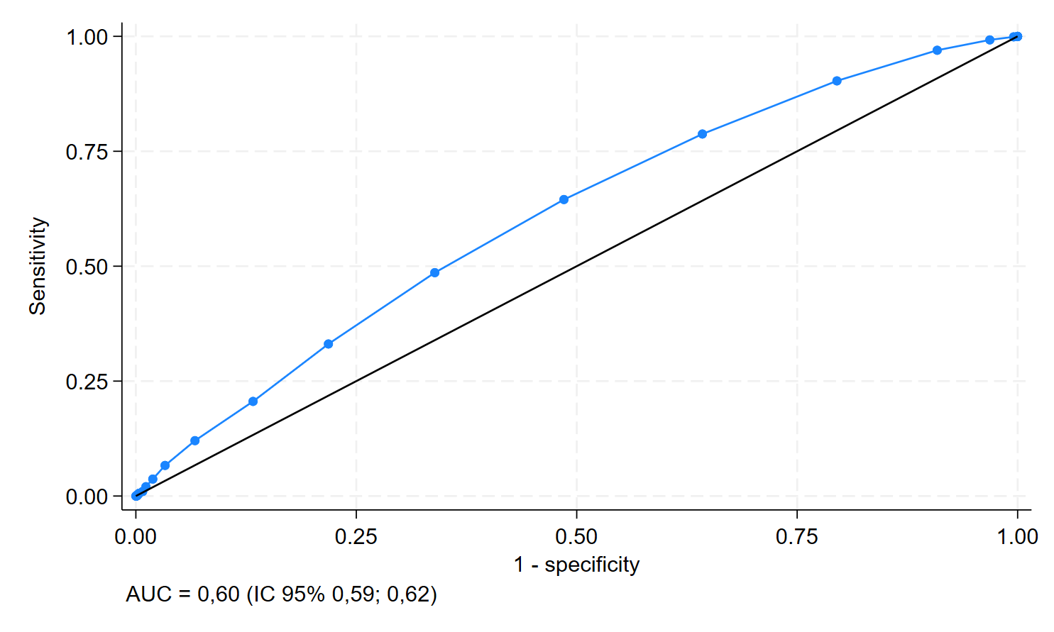**Figura 1.** Curva ROC (Received Operating Curve) da capacidade preditiva do índice TyG para diagnóstico de doença carotídea.

# Gráfico, Gráfico de linhas Descrição gerada automaticamenteDeterminar a relação da gravidade da doença carotídea com índice TyG.

**Figura 2.** Associação da gravidade da doença carotídea com o índice TyG.

# Determinar se a associação de um ou mais fatores de risco com TyG é capaz de prever a existência de doença carotídea e sua gravidade.

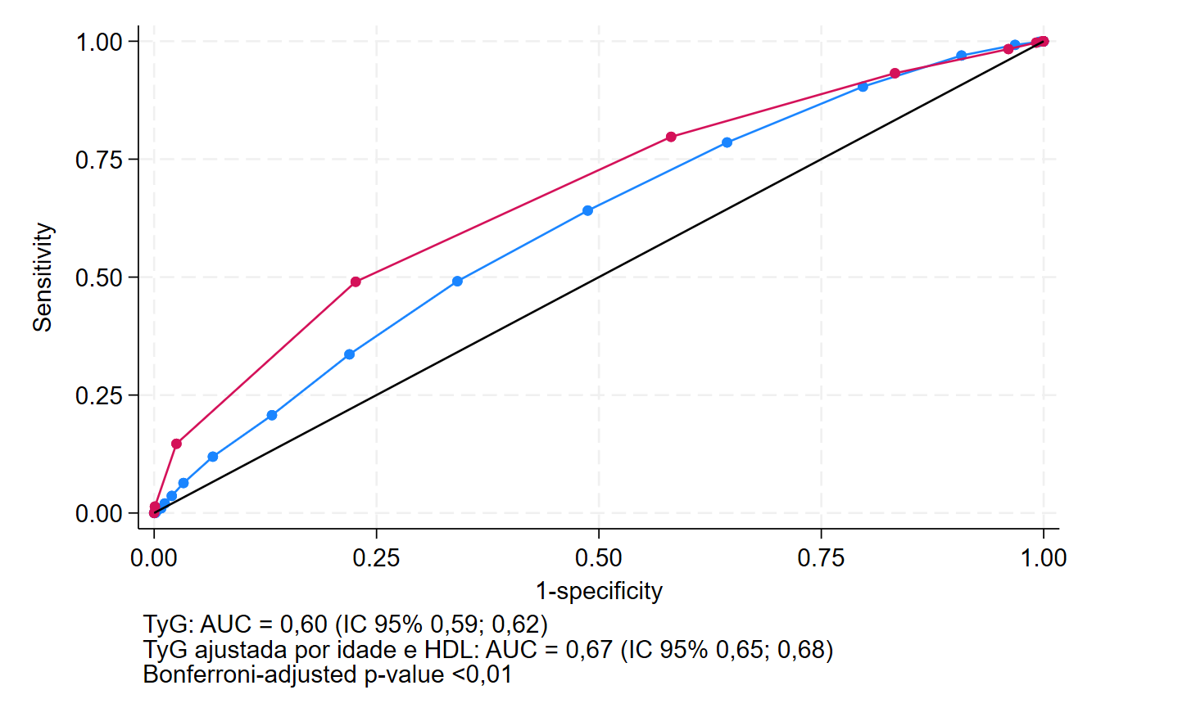

**Figura 3.** Associação da presença de doença carotídea com o índice TyG ajustado por fatores de risco (Idade e HDL).

# Determinar sensibilidade e especificidade do PCR/HDL para diagnóstico de doença carotídea.

**Tabela 4.** Sensibilidade e especificidade do PCR/HDL para diagnóstico de doença carotídea.

|  |  |  |  |  |  |
| --- | --- | --- | --- | --- | --- |
| Cutpoint | Sensitivity | Specificity | classified | LR+ | LR- |
|  |  |  |  |  |  |
| ( >= 0 ) | 100.00% | 0.00% | 42.23% | 1.0000 |  |
| ( >= .1 ) | 99.77% | 0.00% | 42.14% | 0.9977 |  |
| ( >= .2 ) | 95.29% | 4.45% | 42.82% | 0.9973 | 1.0581 |
| ( >= .3 ) | 92.30% | 8.66% | 43.98% | 1.0104 | 0.8897 |
| ( >= .4 ) | 88.97% | 13.28% | 45.24% | 1.0259 | 0.8311 |
| ( >= .5 ) | 85.75% | 16.89% | 45.97% | 1.0317 | 0.8438 |
| ( >= .6 ) | 82.53% | 20.59% | 46.75% | 1.0393 | 0.8486 |
| ( >= .7 ) | 78.74% | 23.53% | 46.84% | 1.0296 | 0.9037 |
| ( >= .8 ) | 77.01% | 26.64% | 47.91% | 1.0498 | 0.8630 |
| ( >= .9 ) | 73.91% | 29.58% | 48.30% | 1.0495 | 0.8821 |
| ( >= 1 ) | 71.03% | 32.44% | 48.74% | 1.0514 | 0.8930 |
| ( >= 1.1 ) | 68.28% | 34.54% | 48.79% | 1.0430 | 0.9185 |
| ( >= 1.2 ) | 66.21% | 36.47% | 49.03% | 1.0421 | 0.9266 |
| ( >= 1.3 ) | 64.60% | 38.74% | 49.66% | 1.0545 | 0.9139 |
| ( >= 1.4 ) | 61.84% | 41.18% | 49.90% | 1.0513 | 0.9268 |
| ( >= 1.5 ) | 60.57% | 42.52% | 50.15% | 1.0539 | 0.9272 |
| ( >= 1.6 ) | 58.85% | 44.03% | 50.29% | 1.0515 | 0.9345 |
| ( >= 1.7 ) | 57.24% | 45.88% | 50.68% | 1.0577 | 0.9319 |
| ( >= 1.8 ) | 55.75% | 47.73% | 51.12% | 1.0665 | 0.9271 |
| ( >= 1.9 ) | 54.48% | 49.33% | 51.50% | 1.0752 | 0.9228 |
| ( >= 2 ) | 53.45% | 50.50% | 51.75% | 1.0799 | 0.9217 |
| ( >= 2.1 ) | 52.18% | 51.26% | 51.65% | 1.0707 | 0.9328 |
| ( >= 2.2 ) | 50.46% | 52.86% | 51.84% | 1.0704 | 0.9372 |
| ( >= 2.3 ) | 49.08% | 54.45% | 52.18% | 1.0776 | 0.9351 |
| ( >= 2.4 ) | 47.82% | 56.13% | 52.62% | 1.0901 | 0.9296 |
| ( >= 2.5 ) | 46.09% | 57.56% | 52.72% | 1.0861 | 0.9365 |
| ( >= 2.6 ) | 44.94% | 58.57% | 52.82% | 1.0848 | 0.9400 |
| ( >= 2.7 ) | 43.33% | 59.92% | 52.91% | 1.0811 | 0.9458 |
| ( >= 2.8 ) | 43.10% | 61.09% | 53.50% | 1.1078 | 0.9313 |
| ( >= 2.9 ) | 42.64% | 61.68% | 53.64% | 1.1129 | 0.9299 |
| ( >= 3 ) | 41.49% | 63.11% | 53.98% | 1.1248 | 0.9271 |
| ( >= 3.1 ) | 40.92% | 64.54% | 54.56% | 1.1539 | 0.9154 |
| ( >= 3.2 ) | 39.77% | 65.38% | 54.56% | 1.1487 | 0.9213 |
| ( >= 3.3 ) | 39.20% | 66.05% | 54.71% | 1.1545 | 0.9206 |
| ( >= 3.4 ) | 38.39% | 66.72% | 54.76% | 1.1537 | 0.9234 |
| ( >= 3.5 ) | 37.59% | 67.56% | 54.90% | 1.1587 | 0.9238 |
| ( >= 3.6 ) | 37.36% | 68.40% | 55.29% | 1.1823 | 0.9158 |
| ( >= 3.7 ) | 36.55% | 68.91% | 55.24% | 1.1756 | 0.9208 |
| ( >= 3.8 ) | 35.63% | 69.58% | 55.24% | 1.1713 | 0.9251 |
| ( >= 3.9 ) | 34.94% | 70.59% | 55.53% | 1.1880 | 0.9216 |
| ( >= 4 ) | 33.91% | 71.68% | 55.73% | 1.1973 | 0.9220 |
| ( >= 4.1 ) | 33.56% | 72.61% | 56.12% | 1.2252 | 0.9150 |
| ( >= 4.2 ) | 32.41% | 73.19% | 55.97% | 1.2092 | 0.9234 |
| ( >= 4.3 ) | 31.61% | 73.87% | 56.02% | 1.2095 | 0.9259 |
| ( >= 4.4 ) | 31.15% | 74.45% | 56.17% | 1.2193 | 0.9247 |
| ( >= 4.5 ) | 30.46% | 75.04% | 56.21% | 1.2204 | 0.9267 |
| ( >= 4.6 ) | 30.00% | 75.63% | 56.36% | 1.2310 | 0.9256 |
| ( >= 4.7 ) | 29.43% | 76.13% | 56.41% | 1.2330 | 0.9270 |
| ( >= 4.8 ) | 28.51% | 76.81% | 56.41% | 1.2291 | 0.9308 |
| ( >= 4.9 ) | 27.47% | 77.48% | 56.36% | 1.2198 | 0.9361 |
| ( >= 5 ) | 26.78% | 77.98% | 56.36% | 1.2164 | 0.9389 |
| ( >= 5.1 ) | 26.21% | 78.66% | 56.50% | 1.2278 | 0.9382 |
| ( >= 5.2 ) | 25.98% | 78.82% | 56.50% | 1.2267 | 0.9391 |
| ( >= 5.3 ) | 25.17% | 79.24% | 56.41% | 1.2128 | 0.9443 |
| ( >= 5.4 ) | 24.94% | 79.66% | 56.55% | 1.2265 | 0.9422 |
| ( >= 5.5 ) | 24.48% | 80.25% | 56.70% | 1.2398 | 0.9410 |
| ( >= 5.6 ) | 23.79% | 81.01% | 56.84% | 1.2528 | 0.9407 |
| ( >= 5.7 ) | 23.22% | 81.34% | 56.80% | 1.2446 | 0.9439 |
| ( >= 5.8 ) | 23.10% | 81.43% | 56.80% | 1.2440 | 0.9443 |
| ( >= 5.9 ) | 22.18% | 81.51% | 56.46% | 1.1999 | 0.9547 |
| ( >= 6 ) | 21.15% | 81.85% | 56.21% | 1.1652 | 0.9634 |
| ( >= 6.1 ) | 20.34% | 82.10% | 56.02% | 1.1366 | 0.9702 |
| ( >= 6.2 ) | 20.34% | 82.27% | 56.12% | 1.1474 | 0.9682 |
| ( >= 6.3 ) | 19.77% | 82.44% | 55.97% | 1.1257 | 0.9732 |
| ( >= 6.4 ) | 19.20% | 83.03% | 56.07% | 1.1308 | 0.9733 |
| ( >= 6.5 ) | 18.85% | 83.45% | 56.17% | 1.1387 | 0.9725 |
| ( >= 6.6 ) | 18.74% | 83.78% | 56.31% | 1.1552 | 0.9700 |
| ( >= 6.7 ) | 18.05% | 83.87% | 56.07% | 1.1185 | 0.9772 |
| ( >= 6.8 ) | 18.05% | 84.29% | 56.31% | 1.1484 | 0.9723 |
| ( >= 6.9 ) | 17.24% | 84.87% | 56.31% | 1.1398 | 0.9751 |
| ( >= 7 ) | 17.01% | 85.04% | 56.31% | 1.1373 | 0.9759 |
| ( >= 7.1 ) | 16.90% | 85.29% | 56.41% | 1.1490 | 0.9743 |
| ( >= 7.2 ) | 16.55% | 85.55% | 56.41% | 1.1451 | 0.9755 |
| ( >= 7.3 ) | 16.55% | 85.63% | 56.46% | 1.1518 | 0.9745 |
| ( >= 7.4 ) | 16.44% | 85.88% | 56.55% | 1.1643 | 0.9730 |
| ( >= 7.5 ) | 15.75% | 86.22% | 56.46% | 1.1426 | 0.9772 |
| ( >= 7.6 ) | 15.40% | 86.39% | 56.41% | 1.1314 | 0.9793 |
| ( >= 7.7 ) | 15.29% | 86.72% | 56.55% | 1.1514 | 0.9768 |
| ( >= 7.8 ) | 15.17% | 86.97% | 56.65% | 1.1648 | 0.9753 |
| ( >= 7.9 ) | 14.48% | 87.48% | 56.65% | 1.1567 | 0.9776 |
| ( >= 8 ) | 14.25% | 87.56% | 56.60% | 1.1460 | 0.9793 |
| ( >= 8.1 ) | 13.79% | 87.90% | 56.60% | 1.1398 | 0.9807 |
| ( >= 8.2 ) | 13.22% | 87.98% | 56.41% | 1.1000 | 0.9863 |
| ( >= 8.3 ) | 12.53% | 88.49% | 56.41% | 1.0883 | 0.9885 |
| ( >= 8.4 ) | 12.07% | 88.91% | 56.46% | 1.0880 | 0.9890 |
| ( >= 8.5 ) | 11.95% | 88.99% | 56.46% | 1.0859 | 0.9894 |
| ( >= 8.6 ) | 11.95% | 89.16% | 56.55% | 1.1027 | 0.9875 |
| ( >= 8.7 ) | 11.72% | 89.50% | 56.65% | 1.1161 | 0.9864 |
| ( >= 8.8 ) | 11.26% | 89.58% | 56.50% | 1.0810 | 0.9906 |
| ( >= 8.9 ) | 11.15% | 89.58% | 56.46% | 1.0700 | 0.9919 |
| ( >= 9 ) | 11.15% | 89.83% | 56.60% | 1.0965 | 0.9891 |
| ( >= 9.1 ) | 11.03% | 90.00% | 56.65% | 1.1034 | 0.9885 |
| ( >= 9.2 ) | 10.80% | 90.17% | 56.65% | 1.0989 | 0.9892 |
| ( >= 9.3 ) | 10.69% | 90.25% | 56.65% | 1.0966 | 0.9896 |
| ( >= 9.4 ) | 10.57% | 90.42% | 56.70% | 1.1039 | 0.9890 |
| ( >= 9.5 ) | 10.57% | 90.59% | 56.80% | 1.1236 | 0.9872 |
| ( >= 9.6 ) | 10.34% | 90.59% | 56.70% | 1.0991 | 0.9897 |
| ( >= 9.7 ) | 10.34% | 90.67% | 56.75% | 1.1090 | 0.9888 |
| ( >= 9.8 ) | 10.23% | 90.92% | 56.84% | 1.1272 | 0.9873 |
| ( >= 9.9 ) | 10.11% | 90.92% | 56.80% | 1.1145 | 0.9886 |
| ( >= 10 ) | 9.89% | 91.18% | 56.84% | 1.1203 | 0.9884 |
| ( >= 10.1 ) | 9.77% | 91.43% | 56.94% | 1.1398 | 0.9869 |
| ( >= 10.2 ) | 9.54% | 91.85% | 57.09% | 1.1704 | 0.9849 |
| ( >= 10.3 ) | 9.43% | 91.93% | 57.09% | 1.1683 | 0.9852 |
| ( >= 10.4 ) | 9.20% | 92.27% | 57.18% | 1.1894 | 0.9841 |
| ( >= 10.5 ) | 8.85% | 92.44% | 57.14% | 1.1702 | 0.9861 |
| ( >= 10.6 ) | 8.85% | 92.52% | 57.18% | 1.1834 | 0.9852 |
| ( >= 10.7 ) | 8.74% | 92.52% | 57.14% | 1.1680 | 0.9864 |
| ( >= 10.8 ) | 8.62% | 92.52% | 57.09% | 1.1527 | 0.9877 |
| ( >= 10.9 ) | 8.51% | 92.52% | 57.04% | 1.1373 | 0.9889 |
| ( >= 11 ) | 8.16% | 92.86% | 57.09% | 1.1425 | 0.9890 |
| ( >= 11.1 ) | 8.05% | 92.86% | 57.04% | 1.1264 | 0.9903 |
| ( >= 11.2 ) | 7.93% | 93.19% | 57.18% | 1.1652 | 0.9879 |
| ( >= 11.3 ) | 7.82% | 93.28% | 57.18% | 1.1626 | 0.9883 |
| ( >= 11.4 ) | 7.59% | 93.36% | 57.14% | 1.1427 | 0.9899 |
| ( >= 11.5 ) | 7.47% | 93.45% | 57.14% | 1.1398 | 0.9902 |
| ( >= 11.6 ) | 7.36% | 93.53% | 57.14% | 1.1369 | 0.9905 |
| ( >= 11.7 ) | 7.36% | 93.87% | 57.33% | 1.1992 | 0.9870 |
| ( >= 11.8 ) | 7.13% | 93.87% | 57.23% | 1.1617 | 0.9894 |
| ( >= 11.9 ) | 6.90% | 94.12% | 57.28% | 1.1724 | 0.9892 |
| ( >= 12 ) | 6.67% | 94.12% | 57.18% | 1.1333 | 0.9917 |
| ( >= 12.1 ) | 6.55% | 94.20% | 57.18% | 1.1299 | 0.9920 |
| ( >= 12.2 ) | 6.44% | 94.45% | 57.28% | 1.1606 | 0.9906 |
| ( >= 12.3 ) | 6.21% | 94.54% | 57.23% | 1.1363 | 0.9921 |
| ( >= 12.4 ) | 5.98% | 94.62% | 57.18% | 1.1114 | 0.9937 |
| ( >= 12.5 ) | 5.98% | 94.71% | 57.23% | 1.1290 | 0.9928 |
| ( >= 12.6 ) | 5.86% | 94.79% | 57.23% | 1.1251 | 0.9931 |
| ( >= 12.7 ) | 5.63% | 94.87% | 57.18% | 1.0987 | 0.9947 |
| ( >= 12.8 ) | 5.52% | 95.13% | 57.28% | 1.1320 | 0.9932 |
| ( >= 12.9 ) | 5.52% | 95.46% | 57.48% | 1.2158 | 0.9897 |
| ( >= 13 ) | 5.40% | 95.80% | 57.62% | 1.2857 | 0.9875 |
| ( >= 13.1 ) | 5.29% | 95.80% | 57.57% | 1.2584 | 0.9887 |
| ( >= 13.3 ) | 5.17% | 96.05% | 57.67% | 1.3096 | 0.9873 |
| ( >= 13.4 ) | 5.06% | 96.22% | 57.72% | 1.3374 | 0.9867 |
| ( >= 13.5 ) | 5.06% | 96.39% | 57.82% | 1.3996 | 0.9850 |
| ( >= 13.6 ) | 4.94% | 96.55% | 57.86% | 1.4345 | 0.9845 |
| ( >= 13.7 ) | 4.94% | 96.72% | 57.96% | 1.5081 | 0.9828 |
| ( >= 13.8 ) | 4.83% | 96.81% | 57.96% | 1.5118 | 0.9831 |
| ( >= 13.9 ) | 4.71% | 96.81% | 57.91% | 1.4758 | 0.9843 |
| ( >= 14 ) | 4.60% | 96.81% | 57.86% | 1.4398 | 0.9855 |
| ( >= 14.1 ) | 4.60% | 96.89% | 57.91% | 1.4787 | 0.9846 |
| ( >= 14.3 ) | 4.25% | 96.89% | 57.77% | 1.3678 | 0.9882 |
| ( >= 14.4 ) | 4.14% | 96.97% | 57.77% | 1.3678 | 0.9885 |
| ( >= 14.5 ) | 4.02% | 97.06% | 57.77% | 1.3678 | 0.9889 |
| ( >= 14.8 ) | 3.91% | 97.14% | 57.77% | 1.3678 | 0.9892 |
| ( >= 14.9 ) | 3.91% | 97.23% | 57.82% | 1.4093 | 0.9883 |
| ( >= 15.1 ) | 3.91% | 97.31% | 57.86% | 1.4533 | 0.9875 |
| ( >= 15.3 ) | 3.91% | 97.39% | 57.91% | 1.5002 | 0.9866 |
| ( >= 15.4 ) | 3.79% | 97.39% | 57.86% | 1.4561 | 0.9878 |
| ( >= 15.5 ) | 3.79% | 97.48% | 57.91% | 1.5046 | 0.9870 |
| ( >= 15.7 ) | 3.79% | 97.65% | 58.01% | 1.6121 | 0.9853 |
| ( >= 15.8 ) | 3.68% | 97.73% | 58.01% | 1.6211 | 0.9856 |
| ( >= 15.9 ) | 3.68% | 97.82% | 58.06% | 1.6835 | 0.9847 |
| ( >= 16.1 ) | 3.56% | 97.82% | 58.01% | 1.6309 | 0.9859 |
| ( >= 16.2 ) | 3.56% | 97.98% | 58.11% | 1.7668 | 0.9842 |
| ( >= 16.3 ) | 3.56% | 98.15% | 58.20% | 1.9274 | 0.9825 |
| ( >= 16.4 ) | 3.33% | 98.15% | 58.11% | 1.8030 | 0.9849 |
| ( >= 16.6 ) | 3.33% | 98.24% | 58.16% | 1.8889 | 0.9840 |
| ( >= 16.7 ) | 3.33% | 98.32% | 58.20% | 1.9833 | 0.9832 |
| ( >= 16.8 ) | 3.33% | 98.49% | 58.30% | 2.2037 | 0.9815 |
| ( >= 16.9 ) | 3.22% | 98.49% | 58.25% | 2.1277 | 0.9827 |
| ( >= 17 ) | 3.10% | 98.49% | 58.20% | 2.0517 | 0.9838 |
| ( >= 17.2 ) | 2.99% | 98.49% | 58.16% | 1.9757 | 0.9850 |
| ( >= 17.6 ) | 2.87% | 98.57% | 58.16% | 2.0115 | 0.9853 |
| ( >= 17.7 ) | 2.76% | 98.57% | 58.11% | 1.9310 | 0.9865 |
| ( >= 18 ) | 2.53% | 98.57% | 58.01% | 1.7701 | 0.9888 |
| ( >= 18.1 ) | 2.30% | 98.57% | 57.91% | 1.6092 | 0.9912 |
| ( >= 18.3 ) | 2.18% | 98.66% | 57.91% | 1.6243 | 0.9915 |
| ( >= 18.4 ) | 1.95% | 98.66% | 57.82% | 1.4533 | 0.9938 |
| ( >= 18.5 ) | 1.84% | 98.74% | 57.82% | 1.4590 | 0.9941 |
| ( >= 18.6 ) | 1.72% | 98.74% | 57.77% | 1.3678 | 0.9953 |
| ( >= 19.2 ) | 1.61% | 98.82% | 57.77% | 1.3678 | 0.9956 |
| ( >= 19.4 ) | 1.61% | 98.91% | 57.82% | 1.4730 | 0.9948 |
| ( >= 19.6 ) | 1.61% | 98.99% | 57.86% | 1.5958 | 0.9939 |
| ( >= 19.7 ) | 1.49% | 98.99% | 57.82% | 1.4818 | 0.9951 |
| ( >= 20.5 ) | 1.38% | 99.16% | 57.86% | 1.6414 | 0.9946 |
| ( >= 20.9 ) | 1.38% | 99.24% | 57.91% | 1.8238 | 0.9937 |
| ( >= 21.1 ) | 1.38% | 99.41% | 58.01% | 2.3448 | 0.9920 |
| ( >= 21.2 ) | 1.38% | 99.50% | 58.06% | 2.7356 | 0.9912 |
| ( >= 21.5 ) | 1.38% | 99.58% | 58.11% | 3.2827 | 0.9904 |
| ( >= 21.6 ) | 1.26% | 99.58% | 58.06% | 3.0092 | 0.9915 |
| ( >= 22.2 ) | 1.15% | 99.58% | 58.01% | 2.7356 | 0.9927 |
| ( >= 22.4 ) | 1.15% | 99.66% | 58.06% | 3.4195 | 0.9918 |
| ( >= 22.7 ) | 1.03% | 99.66% | 58.01% | 3.0776 | 0.9930 |
| ( >= 23.4 ) | 0.92% | 99.66% | 57.96% | 2.7356 | 0.9941 |
| ( >= 23.9 ) | 0.80% | 99.66% | 57.91% | 2.3937 | 0.9953 |
| ( >= 24 ) | 0.69% | 99.66% | 57.86% | 2.0517 | 0.9965 |
| ( >= 24.1 ) | 0.57% | 99.66% | 57.82% | 1.7098 | 0.9976 |
| ( >= 24.5 ) | 0.46% | 99.66% | 57.77% | 1.3678 | 0.9988 |
| ( >= 25.2 ) | 0.46% | 99.75% | 57.82% | 1.8237 | 0.9979 |
| ( >= 25.4 ) | 0.46% | 99.83% | 57.86% | 2.7356 | 0.9971 |
| ( >= 25.8 ) | 0.34% | 99.83% | 57.82% | 2.0517 | 0.9982 |
| ( >= 26.4 ) | 0.34% | 99.92% | 57.86% | 4.1032 | 0.9974 |
| ( >= 27 ) | 0.23% | 99.92% | 57.82% | 2.7355 | 0.9985 |
| ( >= 29.7 ) | 0.23% | 100.00% | 57.86% | 0.9977 |  |
| ( >= 41.2 ) | 0.11% | 100.00% | 57.82% | 0.9989 |  |
| ( > 41.2 ) | 0.00% | 100.00% | 57.77% | 1.0000 |  |

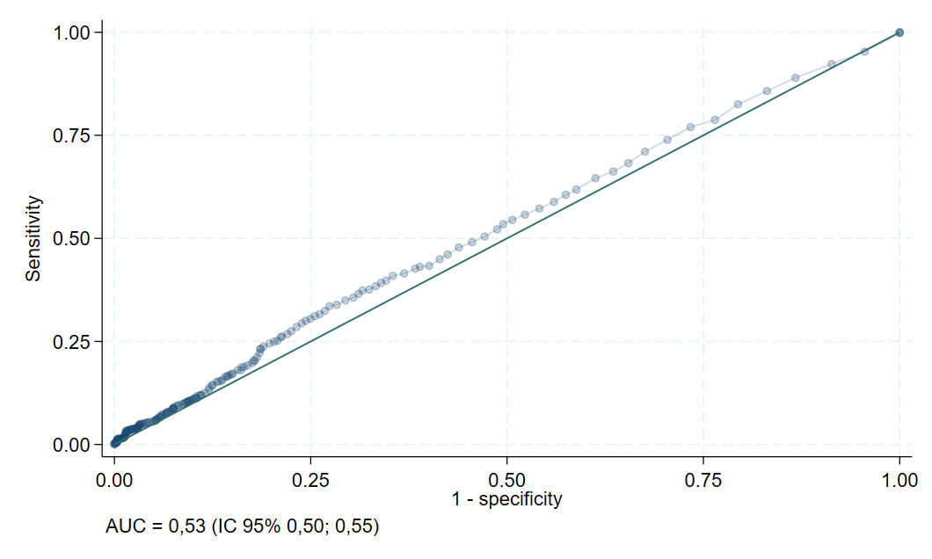

**Figura 4.** Curva ROC (*Received Operating Curve*) da capacidade preditiva do PCR/HDL para diagnóstico de doença carotídea.

# Determinar a relação da gravidade da doença carotídea com HDL/PCR.



**Figura 5.** Associação da gravidade da doença carotídea com o PCR/HDL

# Determinar se a associação de um ou mais fatores de risco com PCR/HDL é capaz de prever a existência de doença carotídea e sua gravidade.

**Figura 6.** Associação da presença de doença carotídea com o PCR/HDL ajustado por sexo, idade e número de fatores de risco.